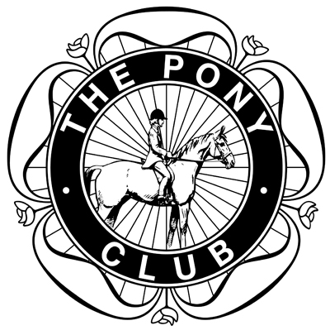

Mid Surrey Pony Club

Area 11 PC70 and PC70 plus and PC 80 Grassroots Eventing Qualifier

Qualifiers for PC70 and PC70 plus and PC80 Regional Championships at Rectory Farm Arena 29th-31st August 2026

SUNDAY 12th July 2026

AT
MID SURREY PONY CLUB FIELD
HURST ROAD
WALTON ON THE HILL
SURREY
KT20 5BN

SECRETARY:
Naomi Kitchener
MOBILE: 07786737370
Email:mspchorsetrials@gmail.com

Online entries only via Entrymaster:

https://midsurreypc.entrymaster.online/index.php?id=1 - event235
Entries close Sunday 5th July 2026

Event information, times, numbers and results available on Pony Club Results:

Available on the day:
Hold & cold refreshments.
Photography.
Vet + Paramedic
ENTRY FEES
All Classes: £60 to include first aid
Booking fees will be applied in addition– see online entry system for details
CLASS NO | DESCRIPTION | OPEN TO | DRESSAGE TEST | SJ MAX  HEIGHT | XC  MAX HEIGHT
1 | PC 70  Pony Club Teams and Individuals aged 13 years and under on 01/01/2026 | Pony Club Members - Teams 3 or 4 competitors and individuals | The Pony Club Foundation PC70 Test 2026 | 75cm | 70cm
2 | PC 70 PLUS  Pony Club Individuals only aged 14 and over | Pony Club Members - individuals | The Pony Club Foundation PC70 Test 2026 | 75cm | 70cm
3 | PC 80  Pony Club Teams and Individuals | Pony Club Members - Teams 3 or 4 competitors and individuals | The Pony Club Grassroots PC80 Test 2026 | 85cm | 80cm

CROSS COUNTRY will be in the Pony Club Field.
DRESSAGE TESTS may be commanded
Tests can be found here: https://pcuk.org/sports/dressage/dressage-tests/
Rosettes Individuals 1st-10th . Teams to 6th place. Rosette for Best Dressage in each section

CONDITIONS OF ENTRY

- The Pony Club Eventing Rules 2026 will apply.
- No horse/pony may compete in more than one class.
- All riders must wear a hat to the current PC standard at all times when mounted. The hat MUST BE TAGGED .Back protector to correct PC standard must be worn for XC. Whips must comply with latest Pony Club rules. Spurs can only be worn by Pony Club Members if they have passed their spurs test AND have a yellow hat tag on the day
- Number bibs required. Can be purchased for £10 on day
- No Stopwatches allowed.
- No unattended horses to be tied to outside of lorries/ trailers
- Combination of horse and rider are NOT eligible if they have: Previously completed at an PC80 or above Area or Regional competition for Eventing OR Achieved more than two cross-country rounds with no jumping penalties at BE (or EI) 80 or above.
REASONABLE ADJUSTMENT : Any requests for Reasonable Adjustment must be made by July 3rd 2026 Mid Surrey DC Gina Kitchener here: mailto:gina@midsurreyponyclub.co.uk
- WITHDRAWALS : Entry fee refunded less £5 admin fee before entry closing date. After closing date, entry fee less £5 admin fee only refunded on production of Vet or Doctor’s certificate.
- In the event of cancellation due to circumstances beyond our control 50% of entry fee per competitor will be withheld for administration costs
- Time available from 7pm on 9th July 2026 on ponyclubresults.co.uk
- The cross country course may be walked the previous day between 2pm and 4pm, or on the day. Please keep clear of competitors on the course
- Teams - best 3 scores will count. DCs or teamManagers to declare branch teams by 6th July 2026
- The Judge's decision is final. Objections to be lodged with the Secretary inwriting within 30 minutes, together with a deposit of £20.00
HEALTH AND SAFETY
- Save for the death or personal injury caused by the negligence of the organisers, or anyone for whom they are in law responsible, neither the organisers of this event nor The Pony Club nor any agent, employee or representative of these bodies, nor the landlord or his tenant, accepts any liability for any accident, loss, damage, injury or illness to horses, owners, riders, spectators, land, cars, their contents and accessories, or any other personal property whatsoever, whether caused by their negligence, breach of contract or in any other way whatsoever. Entries are only accepted on this basis. The organisers of this event have taken all reasonable precautions to ensure the health and safety of everyone present at this event. For these measures to be effective, everyone must take all reasonable precautions to avoid and prevent accidents. They must obey the instructions of the organisers and all officials and stewards.
- PHOTOGRAPHIC RIGHTS:
By entering, competitors and their guardians give permission for any photographic and/or film or TV footage taken of persons taking part in Pony Club events to be used and published in any media whatsoever for editorial purposes, press information or advertising by or on behalf of The Pony Club and/or official sponsors of The Pony Club.

.
We would like to thank the following sponsors for their generous sponsorship of this competition:





AJS Tyres
Kingswood Knoll,
Brighton Road,
Lower Kingswood,
KT20 6XN
01737 241370



